**Project Design Phase**

**Solution Architecture**

|  |  |
| --- | --- |
| Date | 25 June 2025 |
| Team ID | LTVIP2025TMID35341 |
| Project Name | Smart Sorting: Transfer Learning for Identifying Rotten Fruits and Vegetables |
| Maximum Marks | 4 Marks |

## ****Solution Architecture****

**Solution architecture** is a structured approach that bridges the gap between real-world agricultural sorting challenges and advanced technology solutions. Its main goals in this project are:

### ●  Find the best tech solution to solve existing food sorting challenges

**Smart Sorting** leverages **VGG16 (Transfer Learning)** integrated with a **Flask-based web interface** to automate the identification of rotten fruits and vegetables, reducing labor efforts and human error in the quality control process.

### ●  Describe the structure, characteristics, behavior, and other aspects of the system

The system consists of modules for **image upload**, **preprocessing**, **deep learning-based classification**, and **real-time result display**, optimized for use in food industries, supermarkets, and smart kitchens.

### ●  Define features, development phases, and solution requirements

Key features include:

* Image-based prediction of freshness (Fresh or Rotten)
* Simple UI for uploads and predictions
* Result preview with classification label
* Efficient backend deployment using Flask and Keras

Development Phases:

1. Dataset Collection & Cleaning
2. Transfer Learning Model Training (VGG16)
3. Web Interface & Backend Integration
4. Deployment and Testing

### ●  Provide specifications for how the solution is defined, managed, and delivered

* Accepts fruit/vegetable images as input
* Preprocesses images (resizing to **224×224**, normalization)
* Predicts class label (e.g., **Tomato_Rotten**, **Apple_Healthy**)
* Delivers the result via a responsive **Flask web interface**
* Supports image rendering and result storage for batch review

**Example - Solution Architecture Diagram:**

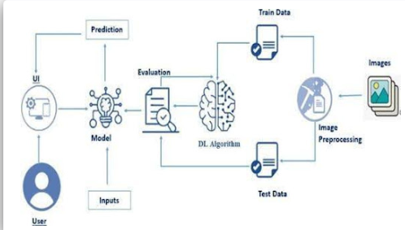

Figure 1: Architecture and Data Flow of Smart Sorting: Identifying Rotten Fruits and Vegetables Using Transfer Learning